

Introduce yourself , take permission
Patient profile Name:
Age:
Marital status: ☐Single ☐ Married ☐ Widowed ☐Divorced
G/P: LMP: EDD: GA:
Blood group:
Occupation:
Chief complaint + duration + Previous similar episodes
HOPI: Analysis of the Chief Complaint
Common CC:
- Vaginal bleeding
Amount (e.g., spotting, heavy flow, clots)
Relation to menstrual cycle/menopause/sexual contact (e.g., intermenstrual, postmenopausal, postcoital)
- Vaginal discharge:
  - Color /Consistency (e.g., frothy, curd-like)/Amount/Smell (e.g., fishy)
- Pruritic and/or erythematous vagina
- Abdominal or pelvic pain:
- Notes: onset/ frequency / progression / Alleviating-Aggravating factors/Associated symptoms
Current pregnancy HX (OBS HX)
- When the pregnancy was diagnosed ?
-How the pregnancy was diagnosed ?
- Wanted ? planned ?
- When/where did you book?
- Follow up (every month)?
*Booking visit includes :
full history ,PE , laboratory tests ( blood group, urine infection, hepatitis , syphilis, AIDS , anemia). US
supplements? folic acid , Vitamin D
folic acid = 400 micro gram till 12 weeks (first trimester), if the pregnancy was planned, she should take it 3 months before.
-fetal movement
-vaginal discharge
-medication , comorbidities ?

any complications ?
Gynecological history :
MENSTRUAL HISTORY
(complete even if post-menopausal or no longer having periods)
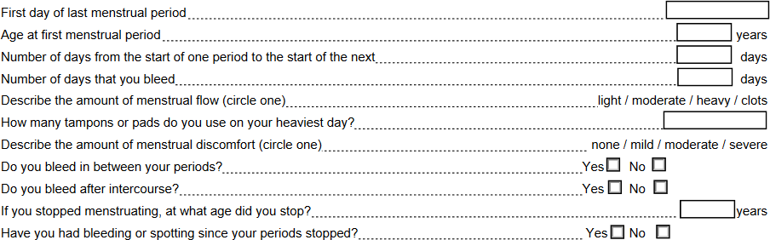

Contraceptive and Sexual History:
Present birth control method:
Complications:
Birth control methods used in the past:
Are you currently sexually active? If no, have you ever been sexually active? History of postcoital vaginal bleeding.
History of sexual dysfunction (e.g., dyspareunia, low libido) Vaginal discharge ? infections ? Previous STD ?

Hx of Pap smear?
Obstetrics Hx
- Past obstetrics history
- each gravida
- was the pregnancy planned ? wanted ? booked ? regular follow up ?
- any complications during pregnancy ?
- the pregnancy full term , preterm ?
- spontaneous vaginal labor? Induction of labor / instruments with delivery (forceps , vacuum) / Cesarean section ?
- any problems during delivery ?
- outcome of delivery? post hemorrhage? depression? infection? fever?
- Baby ( date of birth, sex, birth weight, NICU, duration length of breastfeeding ,what is he doing now)
Past medical and surgical: Hx Chronic diseases , Hx of blood transfusion . Any surgeries or trauma .
Drug & Allergy Hx what he is taking , any recent change , adherence to medications
Family Hx (Ovarian, breast, endometrial, colon) Ca, DM, Htn
Social Hx: Smoking history (# of pack years), alcohol, travel history (Recently), contact with sick patient,
house ventilation, pets.
Review of systems:
general: weight change/appetite change/Fever/recent illness/night sweats/ Fatigue/itch-rash CVS/RS: chest pain/ dyspnea /palpitations/peripheral edema/cough/lightheadedness /LOC GI: Abdominal pain/Nausea-Vomiting/constipation/Diarrhea/Blood per rectum
CNS: headache / seizures / vertigo/ Muscle weakness/numbness/ paraesthesia
GU: Frequency/ dysuria/ urgency /hematuria/polyuria/flank pain. MSS: recent trauma

